SUCCESS
System
Georgia Division of Family & Children Services
&
University of Georgia School of Social Work

SUCCESS Screens
Table of Contents

Basic Information about SUCCESS
- SUCCESS Production Region Security……………………………….. 3
- SUCCESS Security E-mail……………………………………………… 4
- Navigating through SUCCESS ………………………………………… 5
- SUCCESS Function Keys………………………………………………. 6
- Function Key Template ………………………………………………… 7
- SUCCESS Screen Layout ……………………………………………… 8
- Helpful Hints for SUCCESS ……………………………………………. 9
- REMARKS/Documentation …………………………………………… 10
- SUCCESS Trouble Shooting ………………………………………… 11
- SUCCESS Training Region ………………………………………….. 12

SUCCESS Screens, Fields, and Field Information
- Case Background Information ……………………………………….. 13
- SUCCESS Sign-On Procedures ……………………………………... 14
- Screens, Fields, and Field Information ………………………………. 16
- SUCCESS Sign-Off Procedures ……………………………………… 73
- Flow Chart of SUCCESS Screens …………………………………… 74

Accessing the On-line Policy Manual
- Web Site Address and Step by Step Instructions ………………… 75

Welcome to SUCCESS!

SUCCESS is the computer system used by the Division of Family and Children Services to issue benefits for our public assistance programs. SUCCESS is the System for the Uniform Calculation and Consolidation of Economic Support Services. Essentially, this mean that our computer system is designed to consistently issue accurate benefits for the customers we serve provided that the Case Manager has entered the correct data.

As a Case Manager, you are responsible for entering the correct data that accurately reflects your customer’s circumstances. If the data is entered correctly, SUCCESS will correctly determine eligibility. As a data-driven system, SUCCESS uses specific codes to capture your customer’s circumstances and make a determination of eligibility. In addition to the codes entered by the Case Manager, SUCCESS provides space for the entry of documentation to further explain or clarify the customer’s situation.

So, let’s get started!

Success was designed to provide automated eligibility, streamline data entry and reduce fraud. As such, we have three different SUCCESS regions. The first region is the Testing Region. The Testing Region allows our IT professionals to make changes and test the outcomes prior to full installation in the other regions. The second region is the Training Region. The Training Region is an incredible simulation of what Case Managers will use on a daily basis to help our customers. The Training Region allows Case Managers to input data without issuing actual benefits. This is the region that you will use in this session. The last region is the Production Region. The Production Region is the region that is used on a daily basis by Case Managers to make eligibility determinations and issue benefits to our customers. So, there are specific precautionary measures that must be taken to ensure the integrity of what we do.

SUCCESS Production Region Security

- Each employee will be issued his or her own User ID and RACF ID to use to access the SUCCESS system. Please review the “SUCCESS Security” e-mail issued by the Division Director on 05/02/2002. Review the following page.

- Staff who are assigned a SUCCESS USER ID and RACF ID that permits authorization of benefits are legally responsible for all benefits that are authorized under that assigned User ID and RACF ID.

- There are two critical absolutes: (1.) User IDs and RACF IDs are NEVER to be shared or revealed to anyone other than the person to whom it is assigned. (2.) NEVER leave your workstation while signed-on to SUCCESS.

Date: Thursday, 2 May 2002 11:25am ET
To: FIELDDIRECTORS, DFCS.COUNTY.DIRS, SUCCESS.SUPVS
From: DFCS.DIVISION@GOMAIL
Subject: SUCCESS security

Recent events in one of our urban counties have illustrated the need for Division staff at all levels to be cognizant of correct security procedures for SUCCESS user IDs and RACFs. Staff assigned a SUCCESS user ID and RACF which permits authorization of benefits on SUCCESS are legally responsible for all benefits authorized using the assigned ID and RACF. Forms 283 AND 291, completed by all staff to acquire SUCCESS IDs and RACFs, note that the individual is "personally responsible for all actions taken by your UserID/password." IDs and RACFs are never to be shared or revealed to anyone other than the person to whom they are assigned. It is also critical that any person with SUCCESS access never leave her/his workstation while signed on to SUCCESS. Any entry made while signed on is attributed to the person to whom the ID/RACF is assigned, regardless of who may have actually completed the data entry. These security measures are necessary to prevent erroneous benefits from being authorized, case actions being processed in error or invalid cases being established.

It is incumbent upon all management staff at both the Field Area and County levels to insure that correct SUCCESS security procedures are observed in county departments. Every county must insure that terminals are never left unattended while signed on to SUCCESS, to prevent unauthorized issuance of benefits. Counties must also insure that when staff terminate or transfer to other areas that correct security procedures are observed. Field Coordinators will be adding discussions of increased SUCCESS security procedures to their meetings with county directors.

It is my expectation that all counties will review SUCCESS security procedures in every office on a regular basis, and will assure that procedures are in place to prevent unauthorized issuance of benefits on SUCCESS.
-------------( end of letter )--------------------------------------------------

Navigating Through SUCCESS
Using the Keyboard

Let’s look at several keys that are very important when using SUCCESS.
Use the Delete key to delete information in a field one character at a time.
Use the End key to delete ALL the information in a field. It is better to use the End key to delete data, as sometimes the Delete key does not totally delete information.

Use the Pause key to clear the screen.
Use the Enter key next to the letter keypad. DO NOT use the Enter key next to the number pad.

Use the Tab key to move field to field. The Shift key plus the Tab key (pressing both at the same time) will allow you to move back to the previous field.

Use the Esc key to reset the screen when a
appears in the bottom left hand corner of the screen
and a bell tone sounds. This means a mistake has been
made or a command is not recognized by the system.

One way to Navigate through SUCCESS is by using the Function Keys.

The Function Keys are located across the top of the keyboard.

F1 through F12 have set functions that are the same for ALL screens.

F13 through F24 have specific functions used only if the function appears
at the bottom of the screen.

SUCCESS FUNCTION KEYS

HELP If cursor is on a field, this key will provide acceptable codes to use in the field. If cursor is not on a field, this key will provide general information about the screen.

POLICY MANUAL Access the Policy Manual via the Internet at www.odis.dhr.state.ga.us.

EXIT This key will cancel all of the information entered in a case if pressed twice.
BYPASS WARNING MESSAGES

SPA This key will save entered data to the Scratch Pad Area. Only the Case Manager that entered the data can access the case if placed on the SPA.
SCREEN ID LIST This key lists the four character screen ID for each screen in SUCCESS.

PAGE BACK Allows the Case Manager to return to the previous screen.

TRIAL BUDGET/PAGE FORWARD This is a dual function key that will display a trial budget while in a case and allows the Case Manager to scroll forward to the next page if in the Help function.
REMARKS This key is used to access the documentation screen.
ASSISTANCE UNIT LIST This key lists the AU ID numbers for the Head of Household.

CLIENT LIST This key lists the Client ID numbers for each member of the Assistance Unit.
EXIT This key can be used instead of F3.

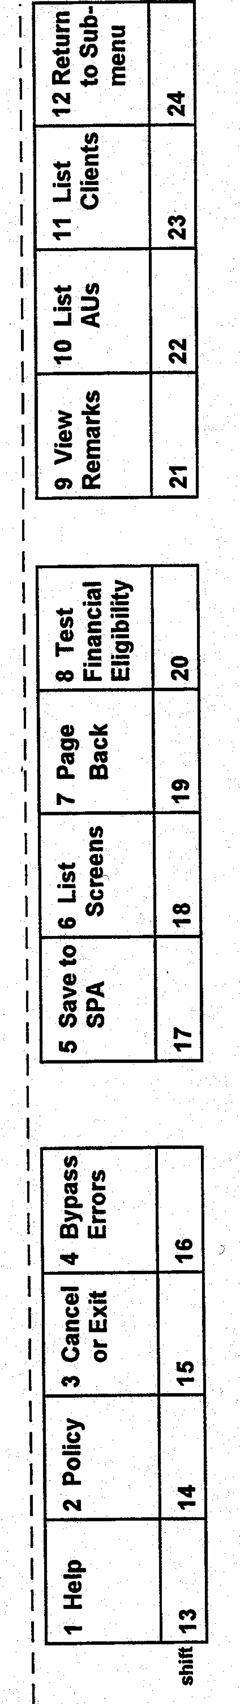
SUCCESS Template for Standard PC Keyboard
Cut on dotted lines. Fold in half lengthwise. Align over keys and tape to keyboard.
RESET
ESC
CLEAR
PAUSE
Screen ID
Client Pointer
Case
Function

Screen Name
Caseload
Number & Date

CHANGE HOUSEHOLD ADDRESSES - ADDR ADDR 01
Month 11 96 1001 10 05 06

CO 047 LO 047 Load ID 1001 Client ID 7653005896 Prev CO/LO
HOH F Name ANN MI M. L Name YOUNG Suf

Auth Prim Voter Visually Hearing Public Hsng/ Serial Census
Field
Content
Rep Lang Reg Impaired Impaired Rent Subsidy Number Tract
Field
Names
N E ? ? N N
Residential Address
Address Line 1 Line 2
Street Number Dir Name Type City Dir Apt
1515 CHESTNUT ROAD
City Atlanta ST GA Zip 30303 Phone 404 312 3443

Mailing Address Del
Address Line 1 Line 2
Street Number Dir Name Type City Dir Apt
Function
Keys

P.O. BOX 521
City Atlanta ST GA Zip 30303
Previous Addresses in last 2 years N
Message 1881 1881
1881 STREET NUMBER OR BOX NUMBER NOT FOUND ON STREET
15-lett 21-narr 23-alau 24-del
Warning
Message

Screen Colors
Yellow – Screen and Field Names Blue – Data that cannot be changed
Green – Data that can be changed White – Warning Messages
Red Question Marks – Mandatory Fields

Helpful Hints for SUCCESS

Moving Past ADDR
In the training region and sometimes in the production region you will be unable to move pass the ADDR screen by just pressing the Enter key. This is because in the training region the ADDR screen cannot interface with the Code-1 Plus System to verify the address. In order to move from ADDR to the next screen, remember to press

The Fast Path Process in SUCCESS
Before you can Fast Path in SUCCESS, you must first know the A/R’s line number and the screen name abbreviation.
To find the A/R’s line number, press which will display the list of clients in the AU.
To find the screen name abbreviation, press which will display a list of all the screen names and their abbreviations.

HOW TO FAST PATH!!
Step 1 Press to take the cursor to the top right hand corner of the screen.

Step 2 Type in the screen name abbreviation and the A/R’s line number. Example: If you want to Fast Path to Demographic Screen 2 for Jim who is on line 3, you would type DEM2 03.

Step 3 Press

REMARKS/Documentation & Text Wrap
Press to enter remarks/documentation behind any screen on SUCCESS. Beginning with the second line of the documentation press
twice, then begin typing. At the end of each text line, press
to move to the next line. Only press Enter when all documentation is completed and you want to return to the SUCCESS Screen.
Policy Manuals Available Online For Use
Website - www.odis.dhr.state.ga.us.
No Password Required
See the Accessing the On-line Policy Manual
for Step by Step Instructions
SUCCESS Trouble Shooting

I’m unable to move forward from ADDR. | Did you press ?
I’ve entered my RACF once, but it will not work. | back to the GO screen and start over, also check your RACF.
I’m unable to move to the next screen. | Check the bottom left corner of the screen, if a displays press
I’m having trouble using the Fast Path steps. | Check the A/R’s line number and the screen name abbreviation in the upper right corner of the screen, then review the Fast Path Steps.
I’m on the DONE screen, but I cannot commit the data, I see the message Eligibility Processing Required. | Did you type a Y to confirm each ELIG and FSFI screen?
I’m on the ERRO screen, how do I resolve the errors. | Type the error code in the Display Error Text field, then Fast Path to the screen to correct.

This training is designed to be an interactive hands-on training. This handbook is designed for your use during and after training.

About the Training Region

The SUCCESS system used in the training region system is a good simulation of the county SUCCESS system. One limitation in the training region is the date is always 10 – 05 – 06. Therefore, the case used during this training is fictitious and will use the date 10 – 05 – 06.

Note: During this training session, you may encounter computer technical problems. As problems occur, refer to the Trouble Shooting page and try to resolve the situation.

Training RACF IDs and Passwords

During this training you will be issued a RACF ID and a Password. These RACF IDs and Passwords can be used only in the Training Region. The number of RACF IDs available for participants in the training region is very limited. You must be extremely careful when signing-on to SUCCESS, because two unsuccessful attempts to sign–on will revoke your RACF ID. If you make a mistake twice while attempting to sign-on, sign off completely and go back to the GO screen to start over.

AU Background

Katherine Norwood receives Medicaid benefits for herself and her two children, Lisa and Joey. Ms. Norwood works part time and Lisa receives direct Child Support.

SUCCESS Sign-On Procedures

GGGGGGGGGGGGGGGGGGG OOOOOOOOOOOOOOOOOOOO
GGGGGGGGGGGGGGGGGGGGG OOOOOOOOOOOOOOOOOOOOO
GGGG GGGG OOOO OOOO
GGGG GGGG OOOO OOOO
GGGG GEORGIA OOOO ONLINE OOOO
GGGG OOOO OOOO
GGGG GGGGGGGGGG OOOO OOOO
GGGG GGGGGGGGGG OOOO OOOO
GGGG GGGG OOOO OOOO
GGGGGGGGGGGGGGGGGGGGG OOOOOOOOOOOOOOOOOOOOO
GGGGGGGGGGGGGGGGGGGG OOOOOOOOOOOOOOOOOOOO

This Network is owned by the State of Georgia and operated
by the Georgia Technology Authority.
(www.gta.ga.gov)
Unauthorized access is prohibited by the Georgia Computer
Systems Protection Act (O.C.G.A 16-9-90, et seq.),
as well as all applicable FEDERAL laws.

The first screen that displays is the GO screen.

In the Training Region, on the GO screen, type CICSV2.

In the Production Region, you would type DHR8.

The next screen that displays is the SUCCESS Sign On Menu.

Press ENTER to advance to the next screen.

Welcome to the Division of Family and Children Services
Integrated Systems Sign On Menu

OP System Description
1 CRS (Client Registration System)
2 $TARS (Support, Tracking, Accounting and Reporting System)
3 EBT (Electronic Benefits Transfer System)
4 SUCCESS (System Uniform Calculation Consolidation Economic Support Services)
5 SUCCINQ (Success Statewide Inquiry)
6 SUCCSTAT (Success Status Messages)
7 PSDS (Protective Services Data System)
8 EAPS (Energy Assistance Program)
9 CCRS (Child Care Reporting System)
10 DIS/MIS (Miscellaneous & Disaster Check System)

Please enter your selection: _____
RACF ID: ___________ PASSWORD:___________ NEW PASSWORD:
Please type in UserId, Password and Option OR Press PF3 to Log Off

On the SUCCESS Sign On Menu, type your Training RACF ID and your Training Password.

Write Here

SUCCESS TRAINING RACF ID ___________________________

SUCCESS TRAINING Password ___________________________

Main Menu

*************************************
** W E L C O M E T O T H E **
*** G E O R G I A ***
*** T R A I N I N G ***
*** S U C C E S S ***
** S Y S T E M **
*************************************

Selection A
Printer ID ????
System Date 10-05-06
Load ID 1895

A. Assistance Unit/Client H. Security O. File Inquiry
B. Supporting Units I. Parameters P. Vendor Files
C. PEACH J. Mass Mod Q. Text
D. Alerts K. Financial Mgmt Iss R. Benefit Error
E. Scheduling L. Lifetime Limit S. AU/Client Misc
F. Letters M. Benefit History
G. Electronic Mail (EMC2) N. Quality Control U. Register IV-D Case

Message 0013
0013 REQUIRED FIELDS ARE IDENTIFIED BY "?"

The SUCCESS Main Menu has several options you can choose. Most often your selection will be the Assistance Unit/Client menu. On this screen you will need to enter your Printer ID number.

NOTE: Your Training Caseload ID number is also listed on this screen.

Write Here

SUCCESS Training Caseload ID number here: ________________

Assistance Unit/Client Sub-Menu

AMEN

ASSISTANCE UNIT/CLIENT SUBMENU - AMEN AMEN
Selection R
AU ID XXXX00184 Client ID
Screen ID As Of Date
Benefit Month (MM YY) Notice Type

A. Name/Part Inquiry J. Registration R. Interim/Hist Change
B. AU/Client Inquiry K. Add A Person S. QRF Change
D. Address Inquiry L. Add A Program Y. Spndwn Med Expnse Update
E. Trial Budget M. Reinstatement Z. Spndwn Med Expnse Inquiry
F. Trial Eligibility N. Initiate Review 1. Spndwn Authorization
G. Batch Print Request O. Interview 5. Prior Medicaid Copy
H. Notice History P. Process Appl Months 6. Finalize Prior Medicaid
I. SPA Inquiry Q. Finalize Application

Message 0013
0013 REQUIRED FIELDS ARE IDENTIFIED BY “?”

The Assistance Unit/Client sub-menu (AMEN) is the starting point for many of the functions completed as a Case Manager.

Enter your Caseload ID number instead of the XXXX.

Household Addresses (ADDR)

ADDR for Katherine Norwood
CHANGE HOUSEHOLD ADDRESSES - ADDR ADDR 01
Month 11 06 1001 10 05 06

CO 049 LO 049 Load ID 1001 Client ID XXXX00269 RES CO
HOH F Name KATHERINE MI Name NORWOOD Suf

Auth Prim Voter Visually Hearing Public Hsng/ Serial Census
Rep Lang Reg Impaired Impaired Rent Subsidy Number Tract
N E N N N Z
Residential Address
Address Line 1 Line 2
Street Number Dir Name Type City Dir Apt
879 CHARTER BLVD
City MACON ST GA Zip 31201 Phone 478 854 7811

Mailing Address Del
Address Line 1 Line 2
Street Number Dir Name Type City Dir Apt
SAME
City ST Zip
Previous Addresses in last 2 years N
Message 1881 1881
1881 STREET NUMBER OR BOX NUMBER NOT FOUND ON STREET
15-lett 21-narr 23-alau 24-del

INFORMATION
The ADDR screen is used to document the residential address of the AU. It is important that addresses be entered correctly on the ADDR screen. SUCCESS compares addresses entered to the Code-1 Plus System for recognition of valid addresses. If the Code-1 System does not recognize the address, an error message will appear when the enter key is pressed. If the AU states the address is correct, PF4 around the error message.

KEY FIELDS
Auth Rep: If the A/R has a personal representative, change the Auth Rep code from an N to a Y. If there is an Authorized Representative, a separate screen will appear where information about the Authorized Representative may be entered.

Residential Address: Enter the Head of Household’s residential address. Address Line 1 field is used only when there is a C/O.

Mailing Address: If the HOH’s mailing address differs from the residential address, enter that information in the mailing address fields. If the mailing address is the same as the residential address, no data should be entered here.

Previous Addresses in last 2 years: Enter a Y to access the PREV screen to enter information on former residences.

- Note: The function keys at the bottom of the screen are F15, F21, F23 and F24. In the production region, F15 – will allow you to send letter; F21 – narrative documentation screen; F23 – will take you to the Alerts; and F24 – can be used to delete a mailing address.

Assistance Status (STAT)
STAT for Katherine Norwood

CHANGE ASSISTANCE STATUS - STAT STAT A
Month 11 06 2001 10 05 06 01

AU ID XXXX00184 Prog MA Prog Type S Prev ABD Type Med COA F01 Claim N
CO 049 LO 049 Load ID 1001 Conversion Date

AU AU Status AU Stat Appl Begin Pd Thru ---Penalty---- Appeal
Stat Reasons Date Date Date Date Type End Date Ind
A 100206 100206 100106

First Last Rel V Mand Finl --Stat—Rsn Appl Begin Pd Thru Penalty
Name Name Incl Resp Date Date Date Date T Date
KATHER NOR SE OT Y RE A 100206 100206 100106
LISA NOR CH OT Y RE A 100206 100206 100106
JOEY NOR CH OT Y RE A 100206 100206 100106

Message
20-rmen 22-alau(arch) 23-alau(curr)

INFORMATION
The STAT Screen is an AU level screen, which displays information regarding the status of the case. Each AU will have a separate STAT screen.

KEY FIELDS
AU Stat: Indicates a code for the current status of the AU. The most commonly used codes are listed below. To access additional codes press F1.

A = active
D = denied
C = closed
M = spenddown
H = closed historically
P = pending

AU Status Reasons: Enter a numeric code from 500 – 579 to manually close/deny an AU. If the system has denied/closed the AU, the code will be a numeric code other than a 500 level code. Do not use code 570 – Call your caseworker; effective 1/27/03, SUCCESS will not allow the entry of this code.

Rel: The relationship code describes each household member’s relationship to the HOH. The most commonly used codes are listed below. To access additional codes press F1.

CH = Dependent Natural or Adopted Child of the Head of Household (HOH)
NS = Spouse to the HOH and no children live in the household
SE = Self - Head of the Household (HOH)
SP = Spouse to the HOH and children live in the household

Finl Resp: The Financial Responsibility code determines how the income and resources of this household member will be counted in the AU. It is crucial that the Finl Resp code is entered correctly. The most commonly used codes are listed below. To access additional codes press F1.

PN = A/R who is applying for some form of Medicaid. Don’t use if the individual does not intend to receive any benefits. Used only at application.
RE = Individual is MA recipient. If the AU status is A and the A/R is not coded as an RE, then that individual is not eligible to receive Medicaid. Case Managers cannot assign a financial responsibility code of RE, the system does this automatically when the AU is approved for any eligible individual coded initially as PN.
NA = Use for all ineligible spouses.
NM = Use when the individual is to have no financial responsibility in the AU. For example, an ineligible child is coded as NM.
NI = Use for an ineligible non-legal spouse.

Stat: A code is assigned by the system to identify the current status of each individual HH member.

Rsn: Closure/Denial reason codes from 500 - 579 are entered in this field to close out an individual HH member, but not necessarily the entire AU. If the system has closed/denied the HH member a system generated code will appear in this field.

Note: The function keys at the bottom of the screen. In the production region, F20 – will take you into the claims sub-menu, F22 – will take you into the archives for alerts, and F23 – will take you into the sub-menu for current alerts.

WORKER ENTERED AU / CLIENT LEVEL REASON CODES

The following are codes workers are able to enter on the STAT screen to deny an AU
or a client.

500 | Reside Community Boarding House
501 | Reside Authorized Institution
502 | Child Member Other TANF Case
503 | Child Member SSI Assist Group
504 | No Child Under Age 18
505 | Disqualified Fail Provide SSN
506 | Household Out of Project Area
507 | Do Not Meet Alien Elig Requirement
508 | Do Not Meet Student Elig Requirement
509 | Resources Exceed Allowed Amount
510 | Income Exceeds Max Amount
511 | Citizenship
512 | Residence
513 | Not Within Degree of Relationship
514 | Child No Longer Deprived
515 | HH Participated Other Project Area
516 | Failed to Apply for Potential Income
517 | No Longer in FC Facility
518 | Not Eligible Med Needy MAO
519 | Employment Hours Exceed Max AF-UP
520 | Program End Due to Federal Law Change
521 | Moved Out of County (FS Only)
522 | Approved for SSI
523 | Client in Nursing Home
524 | AU Suspended for Excess Income
526 | Group Living Arrangement Lost Certification
527 | Group Living Arrangement Lost Authorization
528 | Not Pregnant
549 | Voluntary Withdraw One Program
550 | Voluntary Withdraw All Programs
551 | Whereabouts Unknown
552 | Failed to Provide Info to Determine Eligibility
553 | AU Requested Closure of One Program
554 | You Have Moved
555 | Application Opened in Error
556 | Not Cooperating with QC
557 | AU Requested Closure of All Programs
558 | AU Closed to Approve TANF Cash
559 | Client Discontinued Name Clearance
560 | Ineligible — SSI Pending
562 | Financially Eligible for SSI
563 | Failed to Sign Citizen Declaration
564 | DAIHOH Failed to Comply with E&T
566 | Did Not Cooperate with Eligibility Process
567 | Drug/Alcohol Lost Certification
569 | Placed in Foster Care
570 | Other — Call Your Caseworker (not available for use after 01/03)
571 | ABAWD Ineligible
572 | Failed/Refused to Sign a PRP
573 | TANF — Material Violation, Second Sanction
574 | Ineligible - Employed
575 | Ineligible - Married
577 | Missed Application Deadline
578 | Approved in Other Assistance Program
579 | Received Benefits for the Same Month in Other County.
*598 | Case Closed at Conversation — This is a 500 level reason code but is not worker returned. It is used only on cases converted from PARIS to SUCCESS.

Client Demographic 1 (DEM1)

DEM1 for Katherine Norwood
CHANGE CLIENT DEMOGRAPHIC 1 - DEM1 DEM1 01
Month 11 06 1001 10 05 06

Client Name KATHERINE NORWOOD Suf Client ID XXXX00269

Alt SSA/SSN SSN Appl SSN1 V More DOB V Sex Race Eth
Name Appl For Date SSNs (MM DD YYYY)
522 16 XXXX CS 06 02 1972 CS F B N

GA Marital Living RSM Min Par Boarder Amt Paid -- Family Planning—
Res Status Arrngmt Ad/Ch /LA Num Meals for Meals Referral Date
Y N AH

Concurr SSI Depriv V Prenatal Care ---------- Pregnant --------- FTC
Out of St Recip Ind Good Cse Term/Due Term/Due V Num V Code
CA FS MA Code Date Exp
N N N N

Message
15-lett 16-crs 23-alau

INFORMATION
The DEM1 screen is a client level screen that captures specific information regarding each household member. Much of the demographic information is not required if the individual is not coded with a financial responsibility code of PN.

KEY FIELDS
SSA/SSN Appl For: Code representing the reason why the individual has not applied for a SSN. If the A/R is an undocumented alien, use a code of G or N. Use of R for refusal will result in denial of benefits to the individual.

GA Res: A Georgia residency code of N will result in denial of benefits for the individual.

Marital Status: This code is for documentation purposes only and has no impact on the outcome of the AU.

Living Arrngmt: The living arrangement code is important to ensure that the correct POE is assigned for the homeless and migrant farm workers. The most commonly used codes are listed below. To access additional codes press F1.

AH = The individual resides at home.
BT = Person lives in a battered-spouse shelter.
HL = Homeless.
HS = Homeless shelter.
MI = Migrant/Seasonal Farmworkers

SSI Recip:
N = Use in most instances when the individual has never applied for or received SSI.
SUCCESS uses this field to determine if the person applying for Medicaid benefits is currently receiving Medicaid through the Social Security Administration.

- Note: The function keys at the bottom of the screen. In the production region, F15 – will allow you to send letters, F16 – will allow you to access the CRS system to change an individual’s SSN, date of birth, sex, race, or ethnic information (this information cannot be keyed directly onto the DEM1 screen), and F23 – will take you into the sub-menu for current alerts.

Depriv: This is the field used to indicate that a child is deprived of the care or support of at least one parent. Entry of codes A or B will trigger the display of Absent Parent screens.

A = Absence of One Parent
B = Absence of Two Parents
D = Disability
F = Financial Need – ARM Only
N = Child is Not Deprived
R = Recent Connection to the Workforce
X = Death of One Parent
Z = Death of Two Parents

Client Demographic 2 (DEM2)
DEM2 for Katherine Norwood

CHANGE CLIENT DEMOGRAPHIC 2 - DEM2 DEM2 01
Month 11 06 3981 10 05 06

Client Name KATHERINE NORWOOD Client ID XXXX00269

Citiz V Student V High Grade V Striker ---Immunization -- Law -Health Chk -
Stat Completed Stat Curr GCse Due Dt Brkr Ref Date
C BC N

TPL TPL V ------ Medicare ----- ------ Disability / Incapacity ------
Coop Entitlmnt Claim Num Disab Approval Begin Date End Date
Type Source (MM YYYY) (MM YYYY)
N C CS

Joint Vet Military Death AFDC Cap Parent ------ AFDC Cap Child ----
SSI/FS Stat Serv Num Date Ctr End Date Parnt ID Rcv Mo Cncpt GCse
N

Non-Custodial Parent? V

Message

15-lett 22-tpl 23-alau

INFORMATION
The DEM2 is a client-level screen. It is a continuation of the demographic information obtained on DEM1. Coding the Student Stat field will trigger the ALAS screen.

KEY FIELDS
Citiz: For U.S. citizens, use a code of C. For undocumented aliens who want EMA, use a code of U. Entry of this code will also trigger the ALAS screen.

Student Stat: Complete for any AU members in school. It is also good casework practice to complete this field for all school-age children in the AU. When this field is completed, the ALAS screen will appear to be completed with more student information.

TPL Coop: If the A/R agrees to cooperate with TPL requirements, enter a C. A code of N indicates that the A/R refuses to cooperate.

Disability/Incapacity: These are required fields for any A/R who is disabled/incapacitated and under the age of 60.

Disab Type: Any disability code is acceptable. Access these codes by pressing PF1.
Approval Source: The most commonly used codes are RR, RS, SM, SS, and VA.
Begin Date: Enter the month and four digit year that the A/R was determined disabled.
End Date: Normally a disability end date is not entered unless the A/R is ruled no longer disabled. If an end date is entered, the AU was determined disabled.

Death Date: Enter the month, day, and two-digit year that a household member dies.

- Note: The function keys at the bottom of the screen. In the production region, F15 – will allow you to send letters, F22 – will allow you to enter TPL information for Medicaid cases, and F23 – will take you into the sub-menu for current alerts.

DEM1 for Lisa Norwood
CHANGE CLIENT DEMOGRAPHIC 1 - DEM1 DEM1 02
Month 11 06 1001 10 05 06

Client Name LISA NORWOOD Suf Client ID XXXX00270

Alt SSA/SSN SSN Appl SSN1 V More DOB V Sex Race Eth
Name Appl For Date SSNs (MM DD YYYY)
973 75 XXXX CS 03 19 1990 CS F B N

GA Marital Living RSM Min Par Boarder Amt Paid -- Family Planning—
Res Status Arrngmt Ad/Ch /LA Num Meals for Meals Referral Date
Y N AH

Concurr SSI Depriv V Prenatal Care ---------- Pregnant --------- FTC
Out of St Recip Ind Good Cse Term/Due Term/Due V Num V Code
CA FS MA Code Date Exp
N N N N A CS

Message
15-lett 16-crs 23-alau

DEM2 for Lisa Norwood
CHANGE CLIENT DEMOGRAPHIC - DEM2 DEM2 03
Month 11 06 3981 10 05 06

Client Name LISA NORWOOD Client ID XXXX00270

Citiz V Student V High Grade V Striker ---Immunization -- Law -Health Chk -
Stat Completed Stat Curr GCse Due Dt Brkr Ref Date
C BC N ? 10 05 06

TPL TPL V ------ Medicare ----- ------ Disability / Incapacity ------
Coop Entitlmnt Claim Num Disab Approval Begin Date End Date
Type Source (MM YYYY) (MM YYYY)
N

Joint Vet Military Death AFDC Cap Parent ------ AFDC Cap Child ----
SSI/FS Stat Serv Num Date Ctr End Date Parnt ID Rcv Mo Cncpt GCse
N

Non-Custodial Parent? V

Message

15-lett 22-tpl 23-alau

Remember to press F4 to bypass the warning message.

DEM1 for Joey Norwood
CHANGE CLIENT DEMOGRAPHIC 1 - DEM1 DEM1 03
Month 11 06 1001 10 05 06

Client Name JOEY NORWOOD Suf Client ID XXXX00271

Alt SSA/SSN SSN Appl SSN1 V More DOB V Sex Race Eth
Name Appl For Date SSNs (MM DD YYYY)
913 74 XXXX CS 10 25 2004 CS M B N

GA Marital Living RSM Min Par Boarder Amt Paid -- Family Planning—
Res Status Arrngmt Ad/Ch /LA Num Meals for Meals Referral Date
Y N AH

Concurr SSI Depriv V Prenatal Care ---------- Pregnant --------- FTC
Out of St Recip Ind Good Cse Term/Due Term/Due V Num V Code
CA FS MA Code Date Exp
N N N N A CS

Message
15-lett 16-crs 23-alau

DEM2 for Joey Norwood
CHANGE CLIENT DEMOGRAPHIC - DEM2 DEM2 03
Month 11 06 3981 10 05 06

Client Name JOEY NORWOOD Client ID XXXX00271

Citiz V Student V High Grade V Striker ---Immunization -- Law -Health Chk -
Stat Completed Stat Curr GCse Due Dt Brkr Ref Date
C BC N ? 10 05 06

TPL TPL V ------ Medicare ----- ------ Disability / Incapacity ------
Coop Entitlmnt Claim Num Disab Approval Begin Date End Date
Type Source (MM YYYY) (MM YYYY)
N

Joint Vet Military Death AFDC Cap Parent ------ AFDC Cap Child ----
SSI/FS Stat Serv Num Date Ctr End Date Parnt ID Rcv Mo Cncpt GCse
N

Non-Custodial Parent? V

Message

15-lett 22-tpl 23-alau

Absent Parent Identification (APID)
APID for John Lawrence

CHANGE ABSENT PARENT IDENTIFICATION - APID APID A
Month 11 06 7691 02 01 06 01 More

HOH Name KATHERINE NORWOOD Del AP AP Returned Home N
AP Name JOHN LAWRENCE Suf
SSN Seq Num 00001

Dep First Last Legal Pat Dep First Last Legal Pat Dep First Last Legal Pat
Name Name Rel Type Name Name Rel Type Name Name Rel Type
01 LISA NOR AK NF 02 JOEY NOR NO NO

IV-D --- Good Cause Claim --- Referral 130 Form UCB Other Income
Coop Ind Rsn Stat Date Date Date Ind Types
Y 10 02 06
Union/Local More APs

Message 0013

INFORMATION
The APID screen is an AU-level screen. It is a conditional screen that displays when deprivation information is entered on the DEM1 screen. Information entered on this screen is forwarded to Child Support Services. This screen lists all of the children in the AU identified as deprived of parental support.

KEY FIELDS
AP Name: The name of the Absent Parent is entered.

Legal Rel: Indicates the Legal Relationship of the Absent Parent to the listed child.

Pat Type: Indicates the type of paternity that has been established on this Absent Parent.

IV-D Coop: Indicates that the Head of Household will cooperate in the establishment of paternity for this Absent Parent.

Absent Parent Address (APAD)

APAD for John Lawrence

CHANGE ABSENT PARENT ADDRESS - APAD APAD A
Month 11 06 01

HOH Name KATHERINE NORWOOD Client ID XXXX00269
AP Name JOHN LAWRENCE SSN

Curr Addr Line 1 123 THOMAS DRIVE Line 2
City MACON ST GA Zip 31808 Phone 478 291 6700
Date at Address

Prev Addr Line 1 Line 2
City ST Zip Phone
Date at Address

AP's Father Delete
Street City ST Zip

AP's Mother Delete
Maiden
Street City ST Zip

Message

15-lett 20-next ap 24-del

INFORMATION

This screen is used to identify the Absent Parent’s address and the address of the Absent Parent’s father and mother. All fields are optional, but it is good casework management to enter as much information as is available.

Absent Parent Demographic (APDE)

APDE for John Lawrence

CHANGE ABSENT PARENT DEMOGRAPHIC - APDE APDE A
Month 11 06 01

HOH Name KATHERINE NORWOOD Client ID XXXX00269
AP Name JOHN LAWRENCE SSN

--------- Marital Information --------- Rel HOH Drvr Lic License Plate
Stat Date City ST To AP ST ST Number
FR

DOB Approx ---- Birth Place ---- Sex Race Hgt Hair Eye Wgt
(MM DD YYYY) Age City ST Inches Color Color Lbs
05 15 1970 26 MACON GA M B 74 B N 200

---------------------------- Military Information ----------------------------
Stat ID Num Branch Entry Dt Exit Dt Allotment Pay Allotment Recip

---------------------------- Incarceration Information -----------------------
Cd Release Dt Sentence Lgth Min Confine Institution
Yr Mo Yr Mo
Message

15-lett 20-next ap

INFORMATION

This screen is used to collect available demographic data about the Absent Parent. All fields are optional, but it is good casework management to enter as much information as is available.

Absent Parent Employment (APEM)

APEM for John Lawrence

CHANGE ABSENT PARENT EMPLOYMENT - APEM APEM A
Month 11 06 01

HOH Name KAREN NELSON Client ID XXXX00269
AP Name JOHN LAWRENCE SSN

Primary Employer Delete Occupation PAINTER
Name WALLACE MANAGEMENT Empl Date 01 95
Address Line 1 BARNETT ST Line 2
City MACON ST GA Zip Phone

Secondary Employer Delete Occupation
Name Empl Date (MM YY)
Address Line 1 Line 2
City ST Zip Phone

Former Employer Delete Occupation
Name Empl Date (MM YY)
Address Line 1 Line 2
City ST Zip Phone

Message

INFORMATION

This screen is used to collect any available past or present employment data about the Absent Parent. All fields are optional, but it is good casework management to enter as much information as is available.

Absent Parent Court Order (APCO)

APCO for John Lawrence

CHANGE ABSENT PARENT COURT ORDER - APCO APCO A
Month 11 06 01

HOH Name KAREN NELSON Client ID XXXX00269
AP Name JOHN LAWRENCE SSN

Order Support Support Freq Payee Docket
Date Obligation Arrears Code Number

Paying Date of Last Pymnt Agency Receiving Payment
Support Last Pymnt Amount

Message

15-lett 20-next ap

INFORMATION

This screen collects court-ordered information when it is applicable. All fields are optional, but it is good casework management to enter as much information as is available.

Absent Parent Identification (APID)
APID for Parker Kent

CHANGE ABSENT PARENT IDENTIFICATION - APID APID A
Month 11 06 7691 02 01 06 02

HOH Name KATHERINE NORWOOD Del AP AP Returned Home N
AP Name PARKER KENT Suf
SSN Seq Num 00002

Dep First Last Legal Pat Dep First Last Legal Pat Dep First Last Legal Pat
Name Name Rel Type Name Name Rel Type Name Name Rel Type
01 LISA NOR NO NO 02 JOEY NOR AK NF

IV-D --- Good Cause Claim --- Referral 130 Form UCB Other Income
Coop Ind Rsn Stat Date Date Date Ind Types
Y 10 02 06
Union/Local More APs

Message 0013

Absent Parent Address (APAD)

APAD for Parker Kent

CHANGE ABSENT PARENT ADDRESS - APAD APAD A
Month 11 06 02

HOH Name KATHERINE NORWOOD Client ID XXXX00269
AP Name PARKER KENT SSN

Curr Addr Line 1 UNKNOWN Line 2
City ST Zip Phone
Date at Address

Prev Addr Line 1 Line 2
City ST Zip Phone
Date at Address

AP's Father Delete
Street City ST Zip

AP's Mother Delete
Maiden
Street City ST Zip

Message

15-lett 20-next ap 24-del

Absent Parent Demographic (APDE)

APDE for Parker Kent

CHANGE ABSENT PARENT DEMOGRAPHIC - APDE APDE A
Month 11 06 01

HOH Name KATHERINE NORWOOD Client ID XXXX00269
AP Name PARKER KENT SSN

--------- Marital Information --------- Rel HOH Drvr Lic License Plate
Stat Date City ST To AP ST ST Number
FR

DOB Approx ---- Birth Place ---- Sex Race Hgt Hair Eye Wgt
(MM DD YYYY) Age City ST Inches Color Color Lbs
32 MACON GA M B 72 B N 180

---------------------------- Military Information ----------------------------
Stat ID Num Branch Entry Dt Exit Dt Allotment Pay Allotment Recip

---------------------------- Incarceration Information -----------------------
Cd Release Dt Sentence Lgth Min Confine Institution
Yr Mo Yr Mo
Message

15-lett 20-next ap

Absent Parent Employment (APEM)

APEM for Parker Kent

CHANGE ABSENT PARENT EMPLOYMENT - APEM APEM A
Month 11 06 02

HOH Name KATHERINE NORWOOD Client ID XXXX00269
AP Name PARKER KENT SSN

Primary Employer Delete Occupation PAINTER
Name Empl Date
Address Line 1 Line 2
City ST Zip Phone

Secondary Employer Delete Occupation
Name Empl Date (MM YY)
Address Line 1 Line 2
City ST Zip Phone

Former Employer Delete Occupation
Name Empl Date (MM YY)
Address Line 1 Line 2
City ST Zip Phone

Message

Absent Parent Court Order (APCO)

APCO for Parker Kent

CHANGE ABSENT PARENT COURT ORDER - APCO APCO A
Month 11 06 02

HOH Name KATHERINE NORWOOD Client ID XXXX00269
AP Name PARKER KENT SSN

Order Support Support Freq Payee Docket
Date Obligation Arrears Code Number

Paying Date of Last Pymnt Agency Receiving Payment
Support Last Pymnt Amount

Message

15-lett 20-next ap

Resources 1 (RES1)
RES1 for Katherine Norwood

CHANGE RESOURCES 1 - RES1 RES1 01
Month 11 06 1001 10 05 06 01

Client Name KATHERINE NORWOOD Client ID XXXX000269

Do you have any of the following: cash, money loaned out, checking, savings,
credit union, CD’s, stocks, bonds, or secured notes?
Del Type Amount V Acct Num Institution Name
CA 5.00 CS
CH 78.00 CS WASHINGTON MUTUAL

Do you have any of the following: life insurance, pre-paid burial contracts,
real estate, or cemetery lots?
Del Type Face Amt Cash Amt V Policy Num Company Name
More

Message
15-lett 23-alau 24-del

INFORMATION
There are 3 Resource screens available to document liquid and non-liquid resources. The RES1 screen is used to gather information about the A/R’s liquid resources. Press F1 for a list of resource types.

Resources 2 (RES2)
RES2 for Katherine Norwood

CHANGE RESOURCES 2 - RES2 RES2 01
Month 11 06 1001 10 05 06 01

Client Name KATHERINE NORWOOD Client ID XXXX000269

Do you have any of the following: truck, motorcycle, tractor, farm equipment,
licensed/unlicensed vehicle(s), boat, camper, income producing vehicle?
Del Type Use FMV V Encumb V Yr Make Mod Lic Num Registration
MA/AF FS
MV EM 4125.00 BB 90 TOYOT CORRO
VIN
Do you have any of the following: vacation home, real estate, or rental prop?
Address City ST Zip

Del Use FMV V Encumb V Try Annl Rate V Age Life
to Sell Ret Amt Est Own

More
Message
15-lett 23-alau 24-del

INFORMATION
The Resource 2 screen is used to document information about the A/R’s non-liquid resources. The two questions on this screen specifically collect information on vehicles and real estate. Only one vehicle may be listed on this screen. If the A/R has a second vehicle, enter Y in the MORE field at the bottom-right of the screen and press enter. A blank RES2 will appear.

KEY FIELDS
Type: Enter the appropriate code for the type of vehicle owned. If a vehicle type code is entered, then the Use, FMV, YR, Make, and Model fields are required.

Use: The vehicle use field is for determining how the individual utilizes the identified vehicle.

Encumb: Enter the amount of any encumbrances (claims) against the vehicle, if any. This amount will be subtracted from the Fair Market Value (FMV).

Yr: Enter the two-digit year of the vehicle.

Make: Enter the Manufacturer’s name of the vehicle, such as Ford, Toyota, etc. Up to five characters may be entered.

Mod: Enter the model name of the vehicle, such as Civic, Corolla, etc. Up to five characters may be entered.

Lic Num: Enter the license number of the vehicle. Up to seven characters may be entered. This is an optional field.

Registration: Enter the registration number of the vehicle. This is an optional field.

VIN: Enter the vehicle identification number. This is an optional field.

Resources 3 (RES3)

RES3 for Katherine Norwood
CHANGE RESOURCES 3 - RES3 RES3 01
Month 11 06 01

Client Name KATHERINE NORWOOD Client ID XXXX000269

Do you have any of the following: safety deposit box, business holdings, non-
home consumption produce, livestock, or other valuables?
----------------- Other Property ------------------
Del Type FMV V Encumb V Annl Rate V
Return

More
Message
15-lett 24-del

INFORMATION
The RES3 screen is used to document other resources owned by the A/R but not captured on RES1 or RES2.

KEY FIELDS
Type: Enter the appropriate valid value for the resource owned by the individual.

FMV: Enter the Fair Market Value of the resource entered. This is a required field if a resource type is entered.

Encumb: Enter the amount of any encumbrances (claims) against the resource entered, if any.

Annl Rate Return: Enter the Annual Rate of Return or income generated once a year from this resource. This amount has no effect on the resource value. However, consider if the generated income should be entered as earned or unearned income.

Transfer of Resources (TRAN)

TRAN for Katherine Norwood

CHANGE TRANSFER OF RESOURCES - TRAN TRAN 01
Month 11 06 01

Client Name KATHERINE NORWOOD Client ID XXXX00269

Del Transf Discovery Transferee Resource FMV V Amt V
Ind Date Date R’Ship Type Rec’d
(MM YY) (MM YY)

Reason for Undue Hardship 1st Mth
Transfer Ind Rsn NH/Wvr MA
(MM YY)

More
Message
15-lett 24-del

INFORMATION
The TRAN screen is used to document regarding a transfer of resources, It is a client-level screen. If transfer information is entered, all fields are mandatory on the screen, except for Undue Hardship, which is optional.

KEY FIELDS
Del Ind: Using the delete indicator field will not result in deleting data entered on the TRAN screen. The only time using this field will work is if the Case Manager has not yet exited SUCCESS and committed information to the database. However, data may be deleted by tabbing to each field and pressing the delete or end keys.

Transf Date: Enter the month and two-digit year that the transfer actually occurred.

Discovery Date: Enter the month and two-digit year in which the worker learns of the transfer.

Transferee R’Ship: Enter the appropriate code for the relationship of the person to whom the resource was transferred to the person who did the transfer. Of all the codes available, only using NT, Spouse Not Transferred will not result in a transfer penalty.

Resource Type: Enter the code for the type of resource, which was transferred. All these codes will result in a penalty. If OT (Other Resource) is used, be sure to document.

FMV: Enter the Fair Market Value of the transferred resource and the appropriate verification code. Enter the FMV without commas.

RES1 for Lisa Norwood

CHANGE RESOURCES 1 - RES1 RES1 02
Month 11 06 1001 10 05 06 01

Client Name LISA NORWOOD Client ID XXXX000270

Do you have any of the following: cash, money loaned out, checking, savings,
credit union, CD’s, stocks, bonds, or secured notes?
Del Type Amount V Acct Num Institution Name

Do you have any of the following: life insurance, pre-paid burial contracts,
real estate, or cemetery lots?
Del Type Face Amt Cash Amt V Policy Num Company Name
More

Message
15-lett 23-alau 24-del

RES2 for Lisa Norwood

CHANGE RESOURCES 2 - RES2 RES2 02
Month 11 06 1001 10 05 06 01

Client Name LISA E NORWOOD Client ID XXXX000270

Do you have any of the following: truck, motorcycle, tractor, farm equipment,
licensed/unlicensed vehicle(s), boat, camper, income producing vehicle?
Del Type Use FMV V Encumb V Yr Make Mod Lic Num Registration
MA/AF FS
VIN
Do you have any of the following: vacation home, real estate, or rental prop?
Address City ST Zip

Del Use FMV V Encumb V Try Annl Rate V Age Life
to Sell Ret Amt Est Own

More
Message
15-lett 23-alau 24-del

RES3 for Lisa Norwood

CHANGE RESOURCES 3 - RES3 RES3 02
Month 11 06 01

Client Name LISA NORWOOD Client ID XXXX000270

Do you have any of the following: safety deposit box, business holdings, non-
home consumption produce, livestock, or other valuables?
----------------- Other Property ------------------
Del Type FMV V Encumb V Annl Rate V
Return

More
Message
15-lett 24-del

TRAN for Lisa Norwood

CHANGE TRANSFER OF RESOURCES - TRAN TRAN 02
Month 11 06 01

Client Name LISA NORWOOD Client ID XXXX00270

Del Transf Discovery Transferee Resource FMV V Amt V
Ind Date Date R’Ship Type Rec’d
(MM YY) (MM YY)

Reason for Undue Hardship 1st Mth
Transfer Ind Rsn NH/Wvr MA
(MM YY)

More
Message
15-lett 24-del

RES1 for Joey Norwood

CHANGE RESOURCES 1 - RES1 RES1 03
Month 11 06 1001 10 05 06 01

Client Name JOEY NORWOOD Client ID XXXX000271

Do you have any of the following: cash, money loaned out, checking, savings,
credit union, CD’s, stocks, bonds, or secured notes?
Del Type Amount V Acct Num Institution Name
SV 50.00 CS WASHINGTON MUTUAL

Do you have any of the following: life insurance, pre-paid burial contracts,
real estate, or cemetery lots?
Del Type Face Amt Cash Amt V Policy Num Company Name
More

Message
15-lett 23-alau 24-del

RES2 for Joey Norwood

CHANGE RESOURCES 2 - RES2 RES2 02
Month 11 06 1001 10 05 06 01

Client Name JOEY NORWOOD Client ID XXXX000271

Do you have any of the following: truck, motorcycle, tractor, farm equipment,
licensed/unlicensed vehicle(s), boat, camper, income producing vehicle?
Del Type Use FMV V Encumb V Yr Make Mod Lic Num Registration
MA/AF FS
VIN
Do you have any of the following: vacation home, real estate, or rental prop?
Address City ST Zip

Del Use FMV V Encumb V Try Annl Rate V Age Life
to Sell Ret Amt Est Own

More
Message
15-lett 23-alau 24-del

RES3 for Joey Norwood

CHANGE RESOURCES 3 - RES3 RES3 02
Month 11 06 01

Client Name JOEY NORWOOD Client ID XXXX000271

Do you have any of the following: safety deposit box, business holdings, non-
home consumption produce, livestock, or other valuables?
----------------- Other Property ------------------
Del Type FMV V Encumb V Annl Rate V
Return

More
Message
15-lett 24-del

TRAN for Joey Norwood

CHANGE TRANSFER OF RESOURCES - TRAN TRAN 02
Month 11 06 01

Client Name JOEY NORWOOD Client ID XXXX00271

Del Transf Discovery Transferee Resource FMV V Amt V
Ind Date Date R’Ship Type Rec’d
(MM YY) (MM YY)

Reason for Undue Hardship 1st Mth
Transfer Ind Rsn NH/Wvr MA
(MM YY)

More
Message
15-lett 24-del

Earned Income (ERN1)

ERN1 for Katherine Norwood
CHANGE EARNED INCOME 1 - ERN1 ERN1 01
Month 11 06 1001 10 05 06 01

Client Name KATHERINE NORWOOD Client ID XXXX00269

Do you have any of the following: wages, self employment, commissions/tips,
roomer/boarder income, rent, mortgage payment, sick pay, work program, JTPA,
Job Corps, training allowance, use/sale of personal property, or other income?

Employer Name WALMART AJS Employ N
Line 1 810 SAMS STREET Line 2
City SHELLY ST GA Zip 30211 Phone 229 418 4444
Begin First End Late SON $30+1/3 $30+1/3 $30
Type Date Pay Date Date Rpt Ovrd Ind Cntr End Date End Date
EI 02 01 06 02 15 06 N TANF
LIM N Y 1
RSM

Num of ABD Stdnt TANF Student ------JTPA----
Bordrs Excl Ind Cnt Ind Cnt Excl
More Jobs
Message 5107
5107 DOL DATA IS CURRENTLY UNAVAILABLE - TRY AGAIN LATER.
15-lett

INFORMATION
The ERN1 screen is used to enter the earned income of the household members. The system will count the income according to policy guidelines for the appropriate case type. You may list one employer on this screen. If the A/R has more than one employer, enter a Y in the More Jobs field at the bottom-right of the screen.

SUCCESS will automatically interface with DOL Clearinghouse information. The DOL screen will automatically display. If there is no information available through Clearinghouse, a message will appear at the bottom of the screen.

KEY FIELDS
AJS: This field indicates if the job was the result of an Applicant Job Search.

The Employer Name, Type, Begin Date, First Pay Date and Late Rpt are required fields. Late Rpt should be coded N for the application and ongoing months.

The SON Ovrd, $30+1/3 Ind Cntr, $30+/13 End Date, and $30 End Date fields are used for TANF and Medicaid AUs.

Num of Bordrs: When the Earned Income types of BO and RB are used, it is required to enter the number of borders in the household.

Explanation of earned income Type codes as to how they are counted in eligibility and patient liability/cost share budgets are as follows:

TYPE CODE | COUNTS MA
BO (Earned Income from Boarder) | Y, deducts self-employment expenses
BS (Bonus Severance Pay) | Y
EI (Earned Income) | Y
FM (Farming Income) | Y
GT (Green Thumb) | N
IK (Income In-Kind) | Y
JC (Job Corps) | Y
JT (Job Training Employment Income) | Y
LS (Lump Sum Income) | N
MI (Migrant Worker) | Y
MP (Military Pay) | Y
OA (Other GTSG ARM Countable) | N
OF (Other FS Countable) | Y
OJ (On the Job Training Income) | Y
OM (Other ABD Countable) | N
OT (Other Countable) | Y
PS (Pre Strike Earned Income) | Y
RB (Roomer and Boarder Earned Inc) | Y, deducts self-employment expenses
RI (Rental Income) | Y
RO (Earned Income From Roomer) | Y
SE (Self Employment Earned Income) | Y
SH (Sheltered Workshop Income) | Y
SP (Sick Pay) | Y
SW (Supported Work Income) | NA
TR (Tax Refunds) | N
VI (Visa Payment) | Y
WS (Federal Work Study Income) | Y

Earned Income 2 (ERN2)

ERN2 for Katherine Norwood

CHANGE EARNED INCOME 2 - ERN2 ERN2 01
Month 11 06 1001 10 05 06 01

Client Name KATHERINE NORWOOD Client ID XXXX000269

Employer Name WALMART

Avg Hrs 25 Freq WK Day Week Pd FR Extra Pay
Del
Amt 1 V Amt 2 V Amt 3 V Amt 4 V Extra V
128.75 CH
-------------------------- Work Expenses ----------------------------------
Type Amount Freq V Type Amount Freq V

More Jobs
Message
15-lett 16-evnc 23-alau 24-del

INFORMATION
The ERN2 screen is used to document the amount(s) of earned income. ERN2 is a conditional screen and will only appear if ERN1 has been completed. If the AU member’s earnings fluctuate, press PF16 for the EVNC screen.

KEY FIELDS
Avg Hrs: Enter the average number of hours worked within the pay period.

Freq: Enter the code for the appropriate frequency of pay. The pay will be budgeted for the benefit month shown on a monthly basis, according to the code entered, as follows:

AC (actual): The individual’s pay varies. SUCCESS adds all the amounts entered in the budget.

AN (annually): Individual is paid once a year. SUCCESS budgets only the first amount entered and divides that amount by 12.

BM (bi-monthly): Individual is paid every other month. SUCCESS budgets only the first amount entered and divides by 2.

BW (bi-weekly): Individual is paid every other week.

MO (monthly): Individual is paid once a month. SUCCESS adds all the amounts entered for budgeting.

OT (one-time): This is the only payment the individual will receive. Remove for benefit months in which the individual does not receive. SUCCESS totals all the amounts entered for budgeting.

QU (quarterly): Individual is paid once every three months. SUCCESS budgets the first amount entered and divides that amount by 3.

SA (semi-monthly): Individual is paid twice a month. SUCCESS budgets the first amount entered and multiplies by 2.

WK (weekly): Individual is paid once a week. If only one amount is entered, the system multiplies the amount entered by 4.3333.

Day Week Pd: Optional field for entering the day of the week the AU member is paid. PF1 for the codes for each week day.

Extra Pay: Enter a Y if the month has an extra pay period in it or if the employee receives a bonus. Entering a Y does not affect the budget. SUCCESS will still multiply the first amount by 4.3333.

Work Expenses Fields: The work expenses entered are included with the other earned income deductions.

Type: Enter the appropriate code for the type of work expense. Only three are allowed per screen.

Amount: Enter the dollar amount of the work expense.

Freq: Enter the appropriate frequency code. It must be the same as the frequency of the pay entered on this screen above.

Extra: Enter the dollar amount of a fifth or periodic paycheck, if using Actual Income.

Dependent Care Expenses (CARE)

CARE for Katherine Norwood

CHANGE DEPENDENT CARE EXPENSES - CARE CARE 01
Month 11 06 01

Client Name KATHERINE NORWOOD Client ID XXXX00269

Provider LITTLE RASCALS Phone 912 475 8202
Address 145 HARPER ST City MACON ST GA Zip
More providers
Del Extra Dependent Expense Day of Week Pd FR Rsn EM

Depname Und2 Freq Date Pd Amt Date Pd Amt Date Pd Extra V
JOEY Y WK 10 01 06 10.00
CS

More Dependents For This Provider

Message

15-lett 24-del

INFORMATION

This is a client-level screen used to identify child or adult day care expenses paid by the AR.

KEY FIELDS

Enter the day care provider’s name and address in the Provider, Phone, Address, City, State and Zip fields.

Day of Week Paid: Indicates the day of the week the individual usually pays the expense.

Rsn: Indicates why the individual paying a child care cost.

Depname: Name of child for whom child care is being paid.

Und2: SUCCESS will impose the appropriate maximum amount allowed based on the child’s age.

Freq: Indicates how often the expense is paid.

NOTE: Each child uses two lines, as the verification field is on the second line.

V: how the child care expense was verified.

More Providers: If the AU has another provider, type a Y to display another CARE screen.

ERN1 for Lisa Norwood

CHANGE EARNED INCOME 1 - ERN1 ERN1 02
Month 11 06 2001 10 05 06 01

Client Name LISA NORWOOD Client ID XXXX00270

Do you have any of the following: wages, self-employment, commissions/tips,
roomer/boarder income, rent, mortgage payment, sick pay, work program, JTPA,
Job Corps, training allowance, use/sale of personal property, or other income?

Employer Name AJS Employ
Line 1 Line 2
City ST Zip Phone
Begin First End Late SON $30+1/3 $30+1/3 $30
Type Date Pay Date Date Rpt Ovrd Ind Cntr End Date End Date

TANF
LIM
RSM
Num of ABD Stdnt TANF Student ------JTPA----
Bordrs Excl Ind Cnt Ind Cnt Excl
More Jobs
Message 5107
5107 DOL DATA IS CURRENTLY UNAVAILABLE - TRY AGAIN LATER.
15-lett

ERN2 for Lisa Norwood

CHANGE EARNED INCOME 2 - ERN2 ERN2 02
Month 11 06 2001 10 05 06 01

Client Name LISA NORWOOD Client ID XXXX00270

Employer Name

Avg Hrs Freq Day Week Pd Extra Pay

Del

Amt 1 V Amt 2 V Amt 3 V Amt 4 V Extra V

-------------------------- Work Expenses ----------------------------------
Type Amount Freq V Type Amount Freq V

More Jobs
Message
15-lett 16-evnc 23-alau 24-del

CARE for Lisa Norwood

CHANGE DEPENDENT CARE EXPENSES - CARE CARE 02
Month 11 06 01

Client Name LISA NORWOOD Client ID XXXX00270

Provider Phone
Address City ST Zip
More providers
Del Extra Dependent Expense Day of Week Pd Rsn

Depname Und2 Freq Date Pd Amt Date Pd Amt Date Pd Extra V

More Dependents For This Provider

Message

15-lett 24-del

ERN1 for Joey Norwood

CHANGE EARNED INCOME 1 - ERN1 ERN1 03
Month 11 06 2001 10 05 06 01

Client Name JOEY NORWOOD Client ID XXXX00271

Do you have any of the following: wages, self-employment, commissions/tips,
roomer/boarder income, rent, mortgage payment, sick pay, work program, JTPA,
Job Corps, training allowance, use/sale of personal property, or other income?

Employer Name AJS Employ
Line 1 Line 2
City ST Zip Phone
Begin First End Late SON $30+1/3 $30+1/3 $30
Type Date Pay Date Date Rpt Ovrd Ind Cntr End Date End Date

TANF
LIM
RSM
Num of ABD Stdnt TANF Student ------JTPA----
Bordrs Excl Ind Cnt Ind Cnt Excl
More Jobs
Message 5107
5107 DOL DATA IS CURRENTLY UNAVAILABLE - TRY AGAIN LATER.
15-lett

ERN2 for Joey Norwood

CHANGE EARNED INCOME 2 - ERN2 ERN2 03
Month 11 06 2001 10 05 06 01

Client Name JOEY NORWOOD Client ID XXXX00271

Employer Name

Avg Hrs Freq Day Week Pd Extra Pay

Del

Amt 1 V Amt 2 V Amt 3 V Amt 4 V Extra V

-------------------------- Work Expenses ----------------------------------
Type Amount Freq V Type Amount Freq V

More Jobs
Message
15-lett 16-evnc 23-alau 24-del

CARE for Joey Norwood

CHANGE DEPENDENT CARE EXPENSES - CARE CARE 03
Month 11 06 01

Client Name JOEY NORWOOD Client ID XXXX00271

Provider Phone
Address City ST Zip
More providers
Del Extra Dependent Expense Day of Week Pd Rsn

Depname Und2 Freq Date Pd Amt Date Pd Amt Date Pd Extra V

More Dependents For This Provider

Message

15-lett 24-del

Unearned Income (UINC)

UINC for Katherine Norwood

CHANGE UNEARNED INCOME - UINC UINC 01
Month 11 06 10 05 06 01

Client Name KATHERINE NORWOOD Client ID XXXX000269

Do you have any of the following: RSDI, alimony, direct child support,
contributions, VA, workers compensation, unemployment, sick/disability benefits, pension, railroad retirement, any other retirement, rent, interest, annuities,
dividends, educational income, or striker benefits?

Type Del Freq Claim Number Ded Ded Amt V Extra Pay

Date Rcvd Amount V Date Rcvd Amount V Date Rcvd Amount V

Client Potentially Elig For Other Benefits?
More
Appl Type Stat Date Appl Type Stat Date
Message 5107
5107 DOL DATA IS CURRENTLY UNAVAILABLE - TRY AGAIN LATER.
15-lett 16-uvnc 23-alau 24-del

INFORMATION
The UINC screen is used to gather information on the unearned income of the A/R identified by the client pointer on the screen. Income from one source is entered per screen. If the individual has more than one type of unearned income, access another UINC screen by entering a Y in the More field in the bottom right hand corner of the screen. If an average amount is needed, press PF16 to access the Unearned Variable Income Calculation screen. All AU members will have a UINC screen.

The UINC screen has three functions: (1) Used to gather unearned income for AU members, (2) used to gather information about application for other benefits, and (3) SUCCESS automatically interfaces with Clearinghouse information to check for receipt of UCB, RSDI, and SSI. If there is no information available through Clearinghouse, a message will appear at the bottom of the screen.

KEY FIELDS
Type: Select the appropriate type of income from the list of valid values.

Freq: Enter the appropriate frequency code for the income type entered.

AC (actual): System budgets the actual amount(s) as entered.

AN (annually): SUCCESS divides the total of the actual amount(s) by 12.

BM (bimonthly): SUCCESS uses the first amount entered and divides by 2.

BW (biweekly): SUCCESS uses the first amount entered, divides by 2, and then multiplies by 4.3333.

MO (monthly): System budgets the actual amount(s) as entered.

OT (other): SUCCESS budgets a total of the amounts entered. Delete the income from the system for month(s) in which it should not be budgeted.

QU (quarterly): SUCCESS uses the first amount entered and divides by 3.

SA (semiannually): SUCCESS uses the first amount entered and divides by 6.

SM (semimonthly): SUCCESS uses the first amount entered and multiplies by 2.

WK (weekly): SUCCESS uses the first amount entered and multiplies by 4.3333.

Claim Number: The claim number is only a required field if the income type is either RR or SA. Enter the number and suffix with no spaces or dashes.

Ded: If the individual has items deducted from their pay, enter the appropriate valid value. Press F1 to access the list of deduction codes.

Extra Pay: Enter a Y in this field when an individual gets an extra weekly or biweekly pay.

Date Rcvd: Enter the month, day, and two-digit year that the check is received. This cannot be a date in the future. The date entered will have no impact on the case. If the income is entered for a specific benefit month, it will be counted in the budget unless it is a type code that is disregarded. You may enter up to five payment dates and amounts on this screen.

UINC for Lisa Norwood

CHANGE UNEARNED INCOME - UINC UINC 02
Month 11 06 10 05 06 01

Client Name LISA NORWOOD Client ID XXXX000270

Do you have any of the following: RSDI, alimony, direct child support,
contributions, VA, workers compensation, unemployment, sick/disability benefits, pension, railroad retirement, any other retirement, rent, interest, annuities,
dividends, educational income, or striker benefits?

Type Del Freq Claim Number Ded Ded Amt V Extra Pay
CD MO

Date Rcvd Amount V Date Rcvd Amount V Date Rcvd Amount V
09 01 06 100.00 LE

Client Potentially Elig For Other Benefits?
More
Appl Type Stat Date Appl Type Stat Date
Message 5107
5107 DOL DATA IS CURRENTLY UNAVAILABLE - TRY AGAIN LATER.
15-lett 16-uvnc 23-alau 24-del

UINC for Joey Norwood

CHANGE UNEARNED INCOME - UINC UINC 03
Month 11 06 10 05 06 01

Client Name JOEY NORWOOD Client ID XXXX000271

Do you have any of the following: RSDI, alimony, direct child support,
contributions, VA, workers compensation, unemployment, sick/disability benefits, pension, railroad retirement, any other retirement, rent, interest, annuities,
dividends, educational income, or striker benefits?

Type Del Freq Claim Number Ded Ded Amt V Extra Pay

Date Rcvd Amount V Date Rcvd Amount V Date Rcvd Amount V

Client Potentially Elig For Other Benefits?
More
Appl Type Stat Date Appl Type Stat Date
Message 5107
5107 DOL DATA IS CURRENTLY UNAVAILABLE - TRY AGAIN LATER.
15-lett 16-uvnc 23-alau 24-del

AU Non-Financial Miscellaneous (MISC)

MISC for Katherine Norwood

CHANGE AU NON-FINANCIAL MISCELLANEOUS - MISC MISC A
Month 11 06 2001 10 05 06

HOH Name KATHERINE NORWOOD Client ID XXXX00269
AU ID XXXX00184 Prog MA

Pre Pre AU ATP ATP QRF QRF Pre- Calc Trial Pro Exp SLAM -Extended MA-
Issn EBT Issn Prnt Cyc Status Ctr sump Elig HH Ovr Svc Cd Start Dt COA
Card Mode Cnty Num Code Elig Ind Ind Cor

----- Review ---- Auto ------- Lump Sum Remainder ------ Delay QMB RSM
Compl Mand Last Reasgn Amount 100 % 133 % 185 % Rsn Ovr Elig
Std Type Ovr Ovr

Sched Interview QC Penalty End Date
Del Unit Number XXXX02 Inquiry Date 10 05 06 Load ID
Next Review A Appt Date Appt Type
Appt Begin Time (HH:MM) :
Appt End Time (HH:MM) : Appt Letter Print Location L
L Name/Appt Remarks

Message
13-note 14-schd 15-lett 20-schs 23-alau

INFORMATION
The MISC screen is an AU-level screen and one will appear for each AU. Non-financial information for each AU is shown on this screen. This screen is where review information is found, where appointments may be scheduled, and where issuance information is located.

KEY FIELDS
Calc Elig Ind: Enter a Y if you would like the system to re-run eligibility. Usually the system will do this automatically; however, by entering a Y, this forces the system to look at eligibility again based on current data.

Trial HH Ind: Enter the number of additional members of the household to have the system complete a trial budget to show the impact of these additional members. Use only if running trial eligibility.

Review: The next three fields are to be used upon completion of a review.

Compl: Enter a Y in this field when the review is complete.
Mand Std: Enter either S or A to indicate if the next review should be standard or alternate. If the review type does not match between related AUs, a warning message will appear. If you do not want them to match, press enter/P4 to bypass the error message.
Last Type: This field indicates the review type of the current review.

Auto Reasgn Ovr: This field is pre-populated with an N. If you want to retain this AU on your caseload, change the N to a Y.
Delay Rsn: If this AU is OSOP, enter the appropriate valid value to reflect the reason for the delay. Be sure to document if further explanation is needed.

Sched Interview: The next few fields relate to scheduling or changing an interview.

Del: To delete an interview appointment from the schedule and to delete all information pertaining to the interview, enter a Y and press F24. If the scheduled appointment is a review, be sure to delete it before the 15th of the month to ensure that the appointment letter isn’t mailed.

Inquiry Date: The inquiry date is automatically entered to show the current date. If you wish to inquire on the schedule for a different date, key over the current date with the date for which you wish to inquire and press F14.

Load ID: Enter the caseload ID for the Case Manager conducting the interview.

Next Review: Enter S or A for the type of review. If the system has automatically scheduled the review, it may be changed from this screen. If an alternate review has been scheduled and is subsequently changed to an alternate, the review data will be automatically deleted from the schedule.

Appt Date: Enter the date (MM/DD/YY) for the interview. If this is a system-scheduled standard review, the date will automatically appear in this field. To change this date, simply key over the existing date. This will cause the old date to be removed from the schedule and reappear on the new scheduled day.

Appt Type: Enter the valid value for the type of appointment you wish to schedule. If this is a system determined interview, the code will automatically appear in this field.

Appt Begin/End Time: Enter the time you wish the appointment to begin and end. The appointment times must fall on the hour or half-hour. If the system has automatically scheduled the appointment, the begin and end times will appear in this field. To change the appointment times, key over the existing time to the new time.

L Name/Appt Remarks: Enter the remark you wish to appear on your schedule to alert you to this interview. At a minimum, enter the A/R’s name.

NOTE: To add text to the notice which will be generated, press F13. If this is for a review, be sure to add text prior to the 15th of the month. Also individual schedules, letter templates, unit schedules, and alerts may be accessed from this screen by pressing F14, F15, F20, and F23, respectively.

Consolidated Errors (ERRO)

ERRO for Katherine Norwood

CHANGE CONSOLIDATED ERRORS - ERRO ERRO
01

Display Error Text for This Code
Code Screen AU/Cl Code Screen AU/Cl Code Screen AU/Cl
Pntr Pntr Pntr
0013 DEM2 02
0013 DEM2 03

Message

INFORMATION
The ERRO screen lists all errors found in the case. These errors must be corrected before the data can be committed to the data base. To correct the errors, fast path back to the appropriate screen and correct the data. Refer to the Fastpathing Instructions on page 10.

KEY FIELDS
Display Error Text For This Code: Enter the 4-digit number to find the meaning of the error. Use this field to help problem solve any errors that occur.

Non-Financial Eligibility (ELIG)

ELIG for Katherine Norwood

CHANGE NON-FINANCIAL ELIGIBILITY RESULTS - ELIG ELIG A
Month 11 06 2001 10 16 96 01

AU ID XXXX00184 Prog MA Prog Type F Med COA F01 Confirm Y

AU AU Status AU Stat Appl Begin Pd Thru ---Penalty---
Stat Reasons Date Date Date Date Type End Date
A 100206 100206 100106

First Last Rel V Mand Finl --Stat—Rsn Appl Begin Pd Thru Penalty
Name Name Incl Resp Date Date Date Date T Date
KATHER NOR SE OT Y RP A 100206 100206 100106
LISA NOR CH OT Y RE A 100206 100206 100106
JOEY NOR CH OT Y RP A 100206 100206 100106

Message

INFORMATION
The ELIG screen shows the status of the case and the financial responsibility code for each AU member. This screen should be checked closely for accuracy. If the data is correct, enter Y in the Confirm field. If there is a mistake, do not confirm.

Cash/MA Financial Eligibility (CAFI)

CAFI for 11/06

CHANGE CASH ASSISTANCE FINANCIAL ELIGIBILITY - CAFI CAFI A
Month 11 06 4981 10 05 06
AU ID XXXX00184 Prog MA Prog Type S Med COA F01
Net Income Test (cont)
Resources Standard – 30 1/3 265.97
Resources Limit 1000.00 Dependent Care 43.33
Total Resources 133.00 Net Earned Income 248.61
Gross Income Test Net Unearned Income 50.00
Gross Income Limit 784.40 Deemed Income .00
Gross Earned Income 557.91 Allocated Income .00
Net Unearned Income 50.00 Net Income 299.00
Deemed Income .00 Grant Amount .00
Allocated Income .00 Recoupment Amount .00
Total Gross Income 607.91 Benefit Amount .00
Net Income Test Previous Benefit .00
Net Income Limit 424.00 Spenddown Amount
Gross Earned Income 557.91 Medical Expense Amt
Self Employ Work Exp .00 Net Spenddown Amt
Bnft Eff Date 100206 Bnft Confirm Reasons Budgeting Method P
Notice Type 0011 Waive Timely Notice Period Notice Override
Review Begin Dt 10 06 Review End Dt 04 07 Strat 2

Message

13-note

INFORMATION
The CAFI screen shows the Medicaid budget for the AU.

KEY FIELDS
The Review Begin Dt and Review End Dt fields show the POE assigned by SUCCESS.

Session Summary (DONE)

DONE for Katherine Norwood

CHANGE SESSION SUMMARY - DONE DONE
Month 11 06 01

AU ID Prog Med COA Elig - Status - - Benefit -- Outstanding
Req Code Cfirm Amt Cfirm Verifications
XXXX00184 MA F01 N A

Message 0428
0428 PRESS ENTER TO COMMIT
16-prwp 20-edd 21-narr

INFORMATION
The DONE screen is the last screen. It displays the status and benefit amount for the case. From this screen, data is committed to the database.

SUCCESS Sign-off Procedures

- Press back to the Main Menu

- Press again

- Message will read SUCCESS Session Terminated
- Press to clear the screen

- Type CESF Logoff, then press

ADDR STAT DEM1 DEM2 APID APAD
Conditional
Screen
Conditional
Screen

PREV ALAS

Conditional Conditional
Screen Screen

APDE APEM APCO RES1 RES2 RES3
Conditional
Screen
Conditional
Screen
Conditional
Screen

TRAN ERN1 CARE UINC MISC ERRO

ERN2

Conditional
Screen

ELIG CAFI DONE

+

www.odis.dhr.state.ga.us

Accessing the on-line Policy Manual
Step by Step
Click Favorites toolbar icon at the top of the menu.

Step 1. Open Internet Explorer.

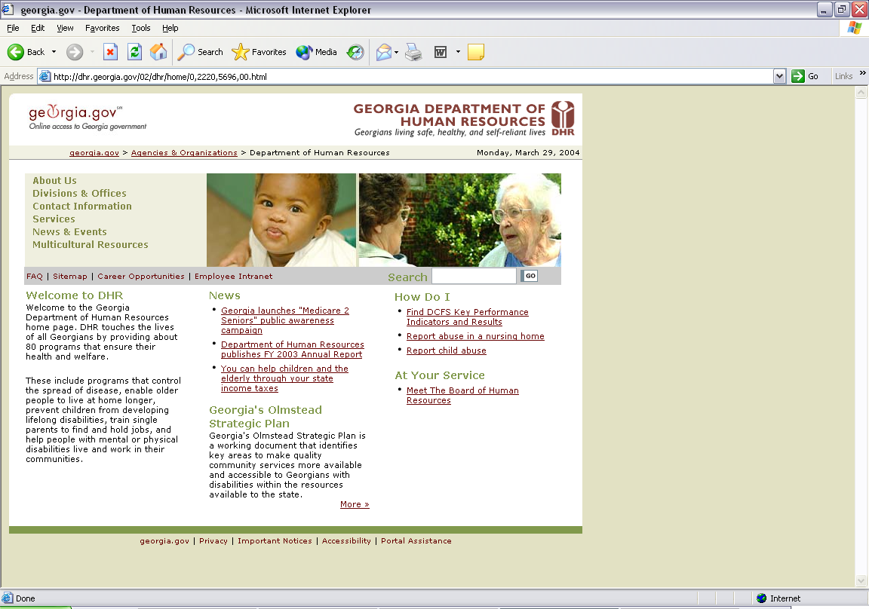

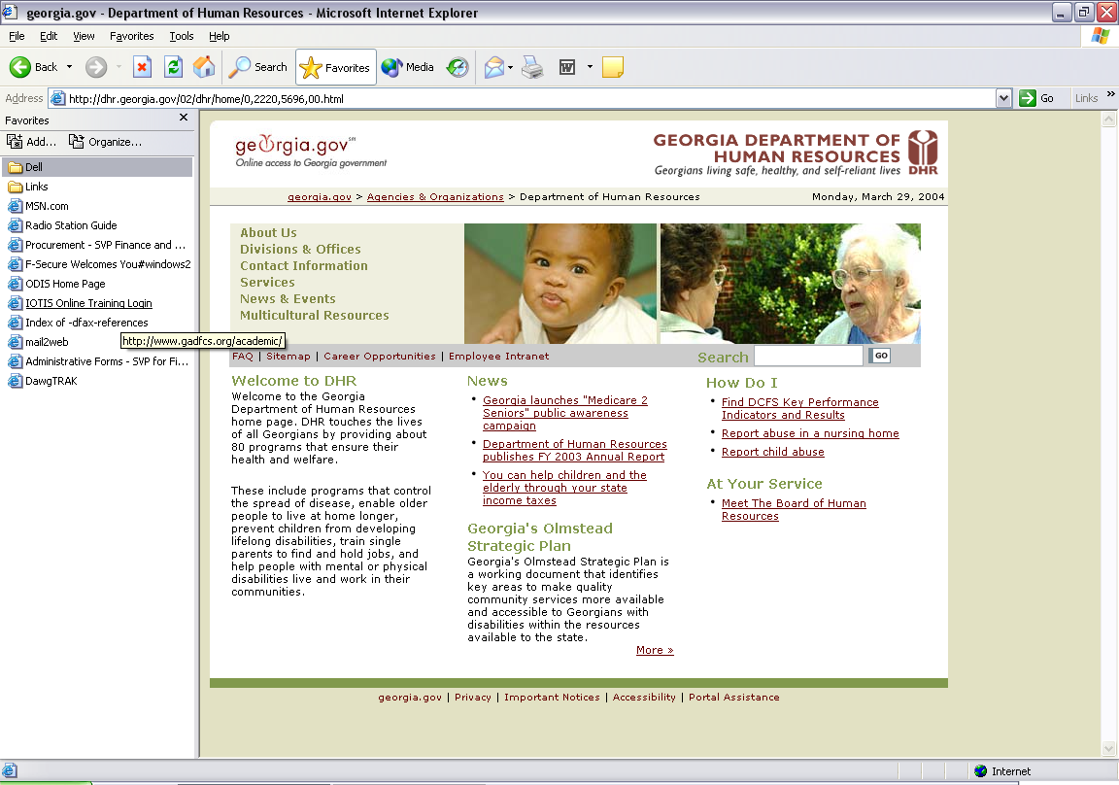
Step 2. Select the On-line Directives Information System.
A side panel will appear. Click on the ODIS Home Page bookmark within this window.

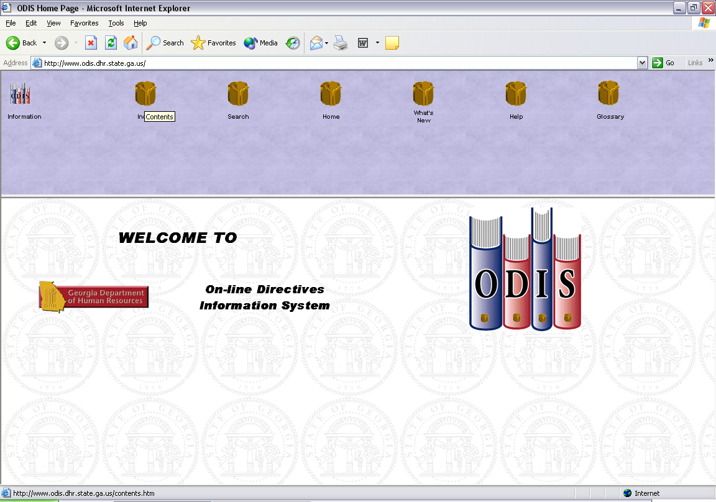
Step 3. Click on the Index icon.
Step 4. Click on the Family and Children Directive.

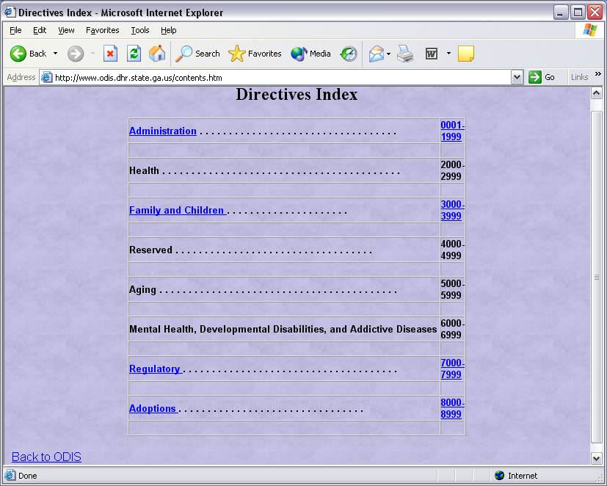

Step 5. Scroll to the Medicaid Directives and click once.

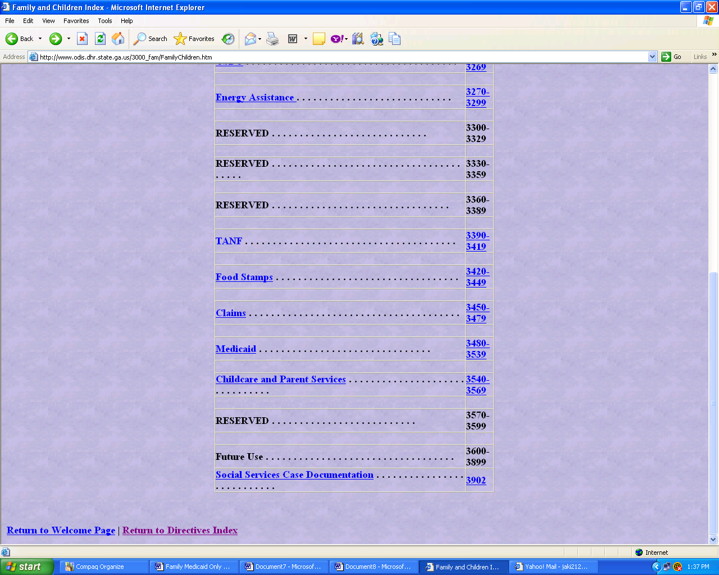
Step 6. Select MAN 3480 and click once.

If asked to Open or Save the file, always select Open.

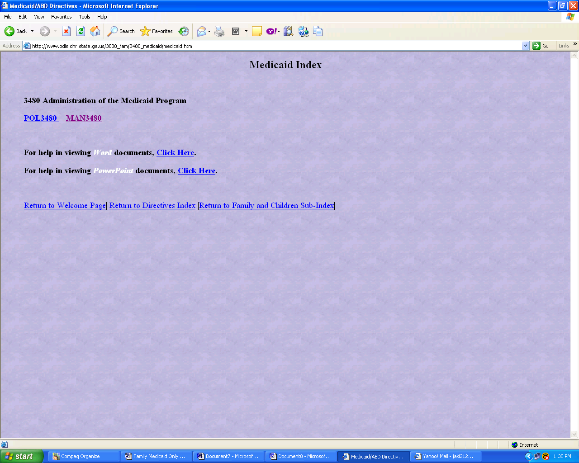

Select MAN 3480 and click once.

Step 7. Scroll to the section of the Policy Manual you want to review, then click on it. Once you have clicked on the
policy section, use the scroll bar to move up and down.
To Return to the Table of Contents or the Family and Children Directives Sub-Index to choose another program, click the Back button.

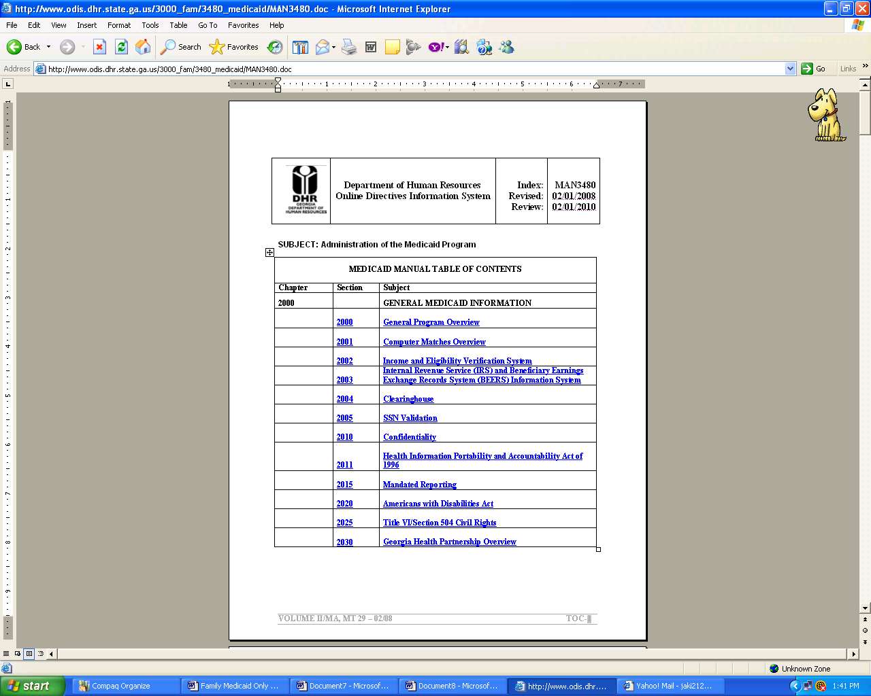

CONGRATULATIONS!

Now that you have viewed each of the SUCCESS screens, feel free to refer to the case information as often as you like to become more familiar with the system.

