PUBLIC NOTICE
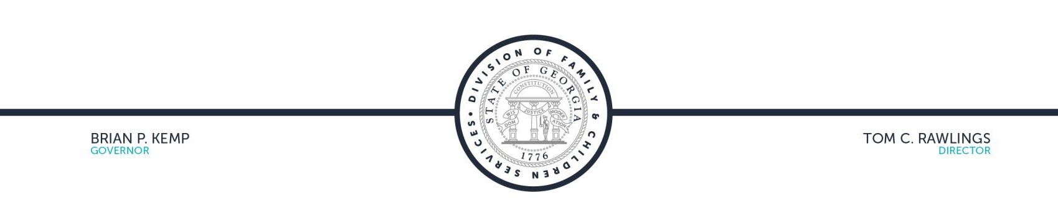

The Georgia Division of Family and Children Services (DFCS) has posted the TANF State Plan Renewal 2020 for public viewing.

Georgia is offering the public the opportunity to send comments on the TANF State Plan Renewal 2020 via email at: melinda.mewbourn@dhs.ga.gov. The comment period ends on January 23, 2020.

To access the report, please click here: http://dfcs.dhs.georgia.gov/temporary-assistance-needy-families

DEPARTMENT OF FAMILY AND CHILDREN SERVICES TWO PEACHTREE STREET | ATLANTA, GA 30303

