Goal Six – Stakeholders

The Division is fully engaged with its stakeholders and responsive to the needs of the community. 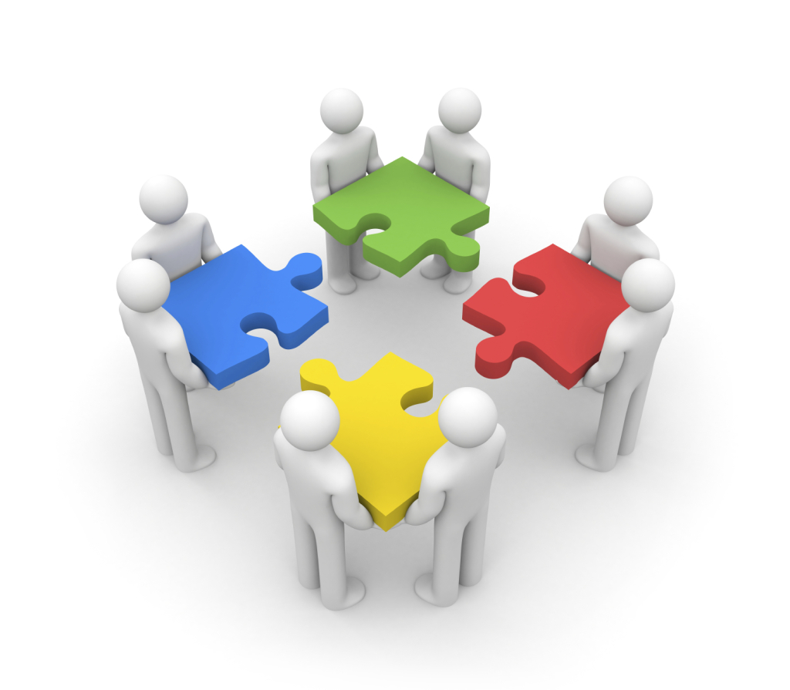

STAKEHOLDER OBJECTIVES

Objective 1: Increase the number of stakeholder groups actively engaged with the Division by July 2024.

Month/Year | Target Measure
July 2020 | 135
July 2021 | 175
July 2022 | 200
July 2023 | 225
July 2024 | 250

Data Source: State of Hope Ecosystem member sites
Data represents the number of Ecosystem member sites added each year.

Objective 2: Increase the number of multidisciplinary and/or interagency
partnerships (at the state and local level) by July 2024.

Month/Year | Target Measure
July 2020 | 5
July 2021 | 10
July 2022 | 15
July 2023 | 20
July 2024 | 25

Data Source: The Office of Strategy, Innovation and Engagement

Objective 3: Reduce the total number of valid complaints received by the Division from 3,687 to 1,796 by July 2024.

Month/Year | Target Measure
July 2020 | 3309
July 2021 | 2931
July 2022 | 2553
July 2023 | 2175
July 2024 | 1,797

Data Source: The Office of Communications and Constituent Services

Objective 4: Increase the number of cash match relationships/agreements from 33 to 60 by July 2024.

Month/Year | Target Measure
July 2020 | 40
July 2021 | 45
July 2022 | 50
July 2023 | 55
July 2024 | 60

Data Source: The Office of Family Independence UAS Budget Report

STAKEHOLDER STRATEGIES

- Implement regular community “Road Shows” at the regional, district and state levels in order to provide consistent and ongoing stakeholder engagement throughout the State.

- Continue implementation of the State of Hope initiative. The State of Hope seeks to activate nonprofits, philanthropies, government, businesses and other community members to collaborate closely to build local safety nets that will prevent conditions that contribute to disparities in education, threaten a family’s self-sufficiency and could lead to child abuse and neglect.

- Develop and implement a plan to consistently engage and partner with philanthropic organizations, faith-based entities and culturally specific groups in support of the Division and its priorities.

- Utilize the statewide Child Welfare Training Collaborative – a partnership between the Division and Georgia State University – in order to provide stakeholders with regular opportunities for consistent and ongoing training.

Adheres to Governor’s Goals of: Safe, Educated and Responsible Government

